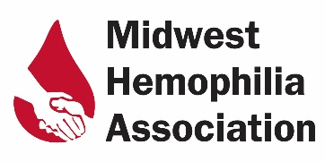

Board Member Nomination-Application Form
Complete this form and return to MHA. This form may be completed by the candidate or someone recommending a candidate.
Candidate Information
First & Last Name |  | Click or tap here to enter text.
Home Address |  | Click or tap here to enter text.
Cell Ph # |  | Click or tap here to enter text.
Email |  | Click or tap here to enter text.
What is your field of employment |  |  | Click or tap here to enter text.
Work Ph # |  | Click or tap here to enter text.
Education |  | Click or tap here to enter text.
Relevant experience and/or employment within bleeding disorders community |  |  |  |  | Click or tap here to enter text.
Relevant civic/business experience and/or employment |  |  |  |  | Click or tap here to enter text.
Why are you interested in serving on the MHA Board of Directors? |  |  |  |  | Click or tap here to enter text.
Areas of expertise/contributions you can make to MHA as a Board Director: |  |  |  |  | Click or tap here to enter text.
Other current volunteer commitments: |  |  |  | Click or tap here to enter text.
Mark any of the following skills or experience that you possess: |  |  |  | Click or tap here to enter text.
List additional affiliations or organizations (e.g. memberships, professional, civic) |  |  |  | Click or tap here to enter text.
Please mark any of the following skills or experience you possess. |  |  |  | ☐Finance, Account ☐Grant Writing  ☐Fundraising ☐Event Planning  ☐Public Relations/Communication  ☐Management, Administration  ☐Nonprofit Experience  ☐Teaching, Curriculum Development  ☐Networking, Contacts  ☐Other: Click or tap here to enter text.
Submitted by: | Click or tap here to enter text.
Date: | Click or tap here to enter text.

Please mail to: Midwest Hemophilia Association
1467 W. South St
Suite C
Ozark, MO 65721

OR email: info@midwesthemophilia.org

